**Git Assignment Day-3**

**GIT BRANCHING**

git branch

git branch done1

git checkout done1

ls -ltr

touch 1.txt 2.txt

git add 1.txt 2.txt

git commit -m "second commit branch"

git merge done1

git remote add origin <https://github.com/DevendarReddy2001/gitdb22/tree/done11.git>

git push origin done1

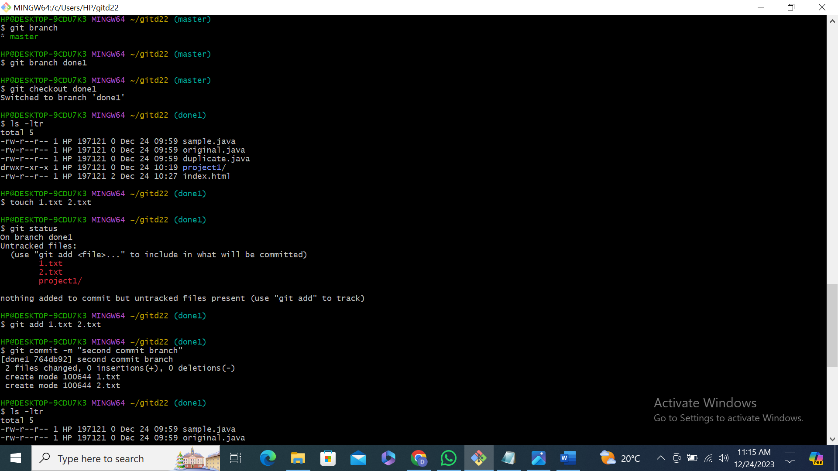

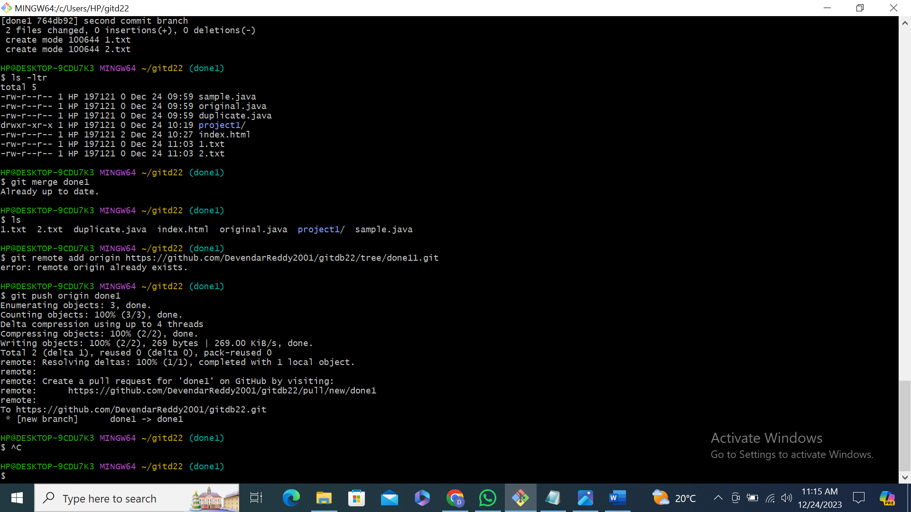

Git branch done1 in git hub

